MEMBERSHIP REGISTRATION FORM – FRENCH GLYCOSCIENCES GROUP

MEMBERSHIP FEE 2026 et 2027
Membership fees can be paid either by purchase order, sent to the treasurer (vincent.ferrieres@ensc-rennes.fr), or by bank transfer to the GFG account (see bank details on p. 2)
SURNAME: |  | First name:
Position
Laboratory
Team
Postal address
Telephone number
e-mail
Situation | Permanent position in a public laboratory  (researcher, lecturer-researcher, technical staff)  - Fee: 40 €  (for 2 years) | Private sector position  (CDD, CDI)  - Fee: 40 €  (for 2 years) | Public service contractual employee  (doctoral students, post-doctoral fellows, other contractual positions)  Attach proof  - Fee: 30 €  (for 2 years)
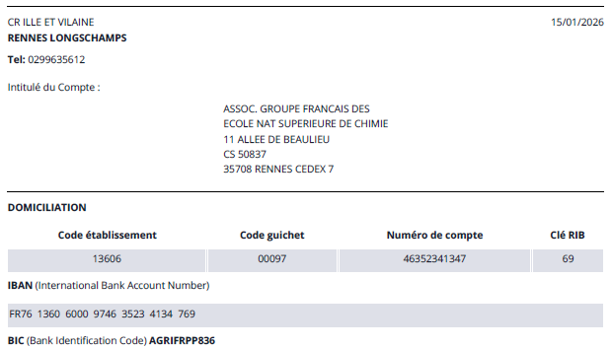
Nouvelle banque : Crédit Agricole d’Ille et Vilaine

